IT 5434 Network Security Fundamentals
Lab Assignment 11 (L11)

Wi-Fi Security Evaluation

60 (+ up to 20 bonus) points Due: see due date under Dropbox on Folio
Emmanuel Opara
901305850

At anytime and anywhere, you can only ethically hack (evaluate the security of) a Wi-Fi network where you are fully authorized to do so. Hacking networks when you are not authorized may involve you in legal issues.

- Go to https://wigle.net/. Search the wireless networks in Statesboro on the map. (18 points)
  - Give the SSID and BSSID (may need to zoom in to find it) of one of the Wi-Fi access points inside (or near) the IT Building. Provide screenshot.

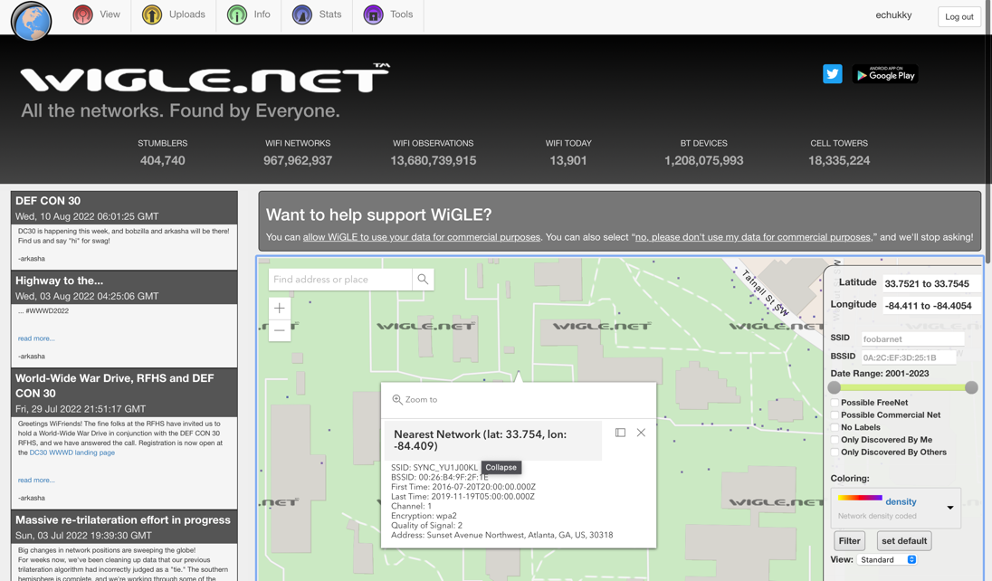

  - On the map, locate a restaurant/store in town you have been to that has a Wi-Fi SSID/BSSID listed on this map. What restaurant/store is it? What is the SSID and BSSID? Attach screenshot(s).

Restaurant name: Grubhub
SSID: Foobarnet
BSSID: 0A:2C:EF:3D:25:1B
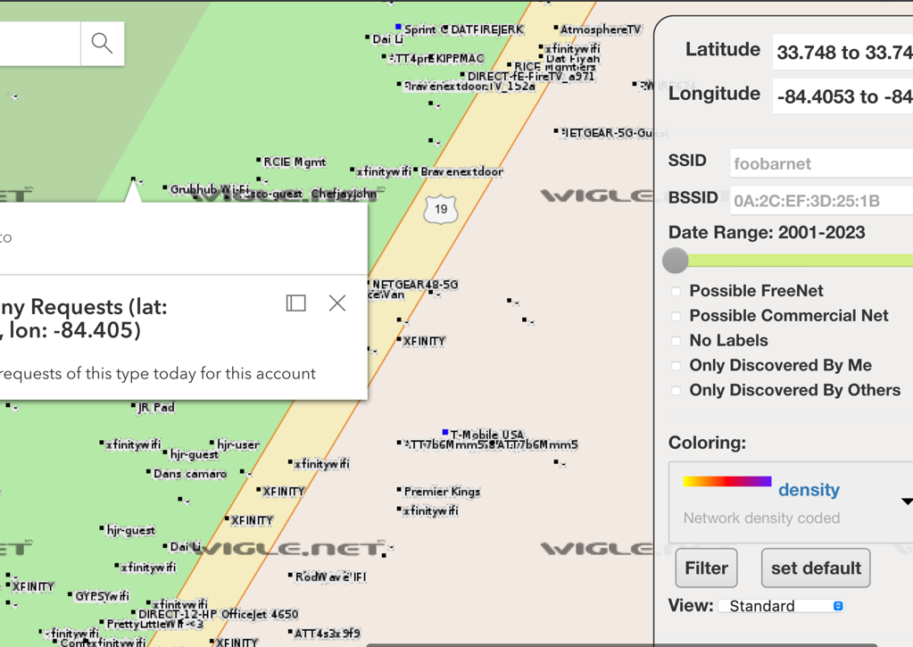

  - In the “Statistics Over Time” provided by Wigle, specify the percentiles of the following Wi-Fi networks for the latest date on the chart: Unencrypted, Encrypted, WEP, WPA, WPA2 and WPA3? What is the latest date shown on the chart? Attach screenshot.
Unencrypted: 2.37
Encrypted: 17.63%
WEP: 3.82%
WPA: 3.73%
WPA2: 72.48%
WPA3:0.03%
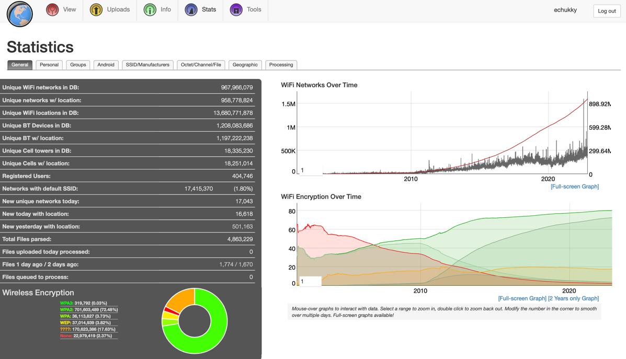

- Use a software (e.g., the inSSIDer 3.1.2.1, https://www.techspot.com/downloads/5936-inssider.html) to scan the Wi-Fi networks around where you live or work. Obviously, you will need a computer/laptop with Wi-Fi capability to complete this task. (14 points)
  - How many Wi-Fi networks are detected, how many of them are encrypted, and how many of them are protected using WEP, WPA, and WPA2 respectively (you can sort the networks by columns)? Do these numbers roughly match to the statistics from Wigle? Attach screenshot(s).

I utilized an application called “WIFI Console by Ambeent”. From this screenshot, we can see the various wifi networks in the neighborhood. The statistics match with wiggle, because I could see the same number of wifi routers using this application. Some certain details were restricted because it requires a payment plan to view certain details.
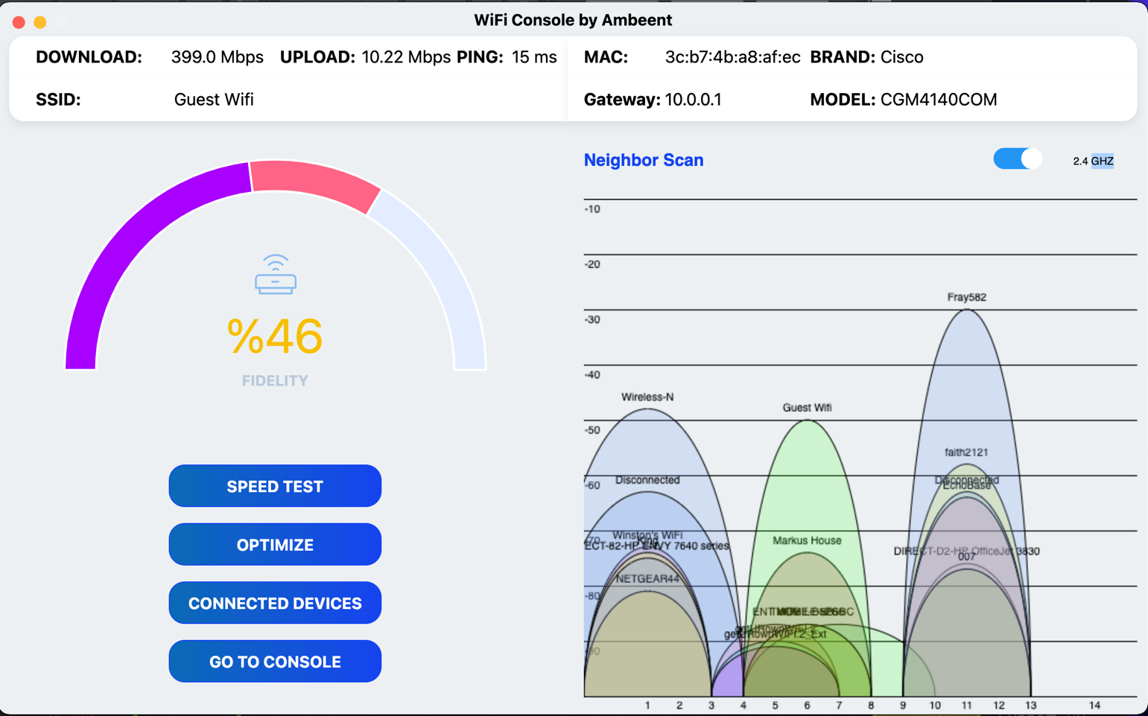

  - Specify the details, e.g., the BSSID, ESSID, channel(s), signal strength, security type/mode, of a specific Wi-Fi network detected. Attach screenshot(s).
BSSID: 3c:b7:4b:a8:af:ec
SSID: Guest Wifi
Channel: 157 (5GHz, 80MHz)
signal strength: -56 dBm
security type/mode: IEEE 802.11ac(Wifi 5)
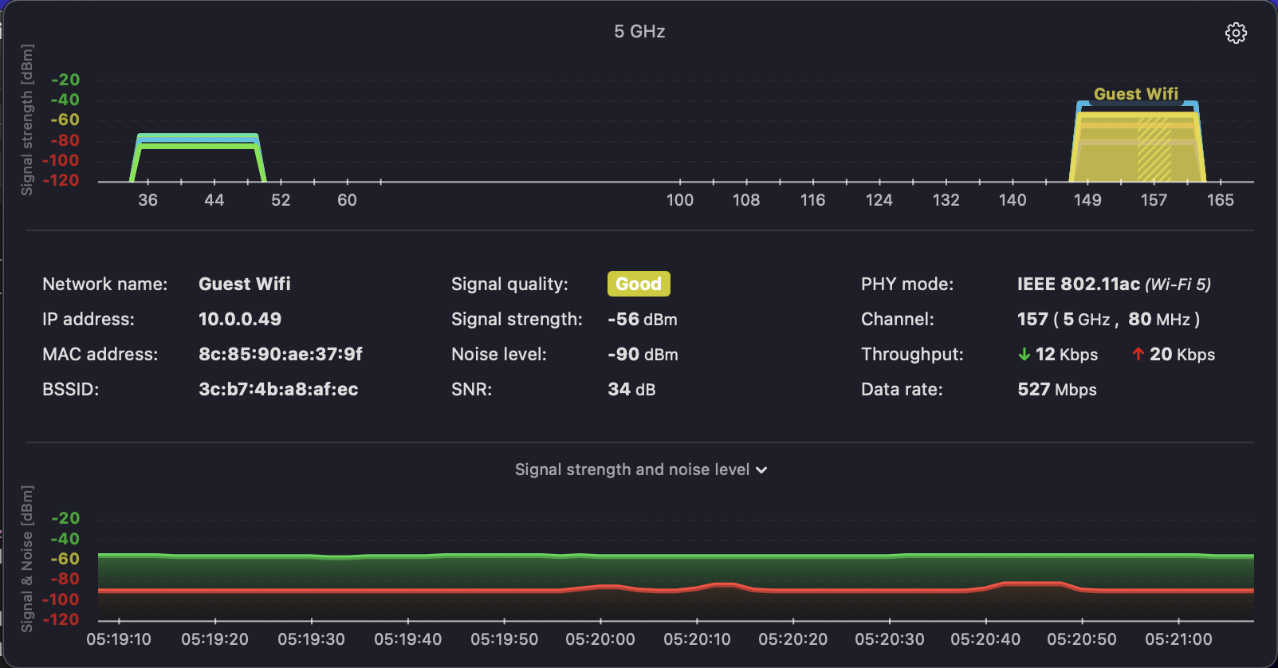

- For this task, you will need the administrator’s privilege access to a wireless router. If you don’t have a Wi-Fi router or access point with administrator’s access, you may use this Wi-Fi router emulator https://emulator.tp-link.com/Archer-C9/Index.htm. (28 points)
  - What mode (e.g., a, b, g, n, ac, ax etc.) is the Wi-Fi network running in? What are the available Wireless Security Types that can be found in the router?

Mode: 11a/n/ac mixed
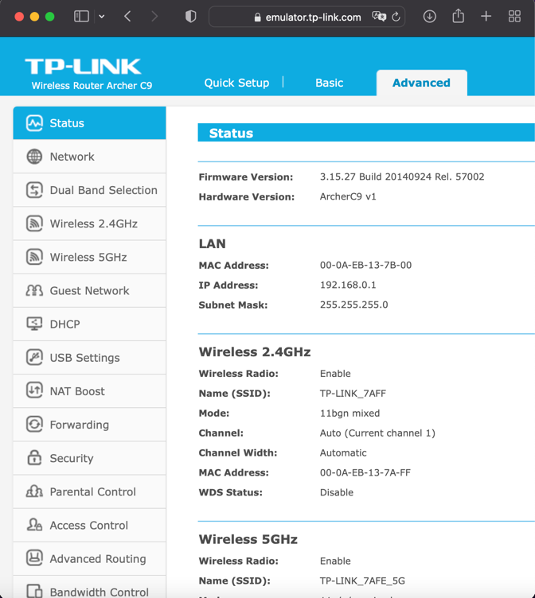

Security type:
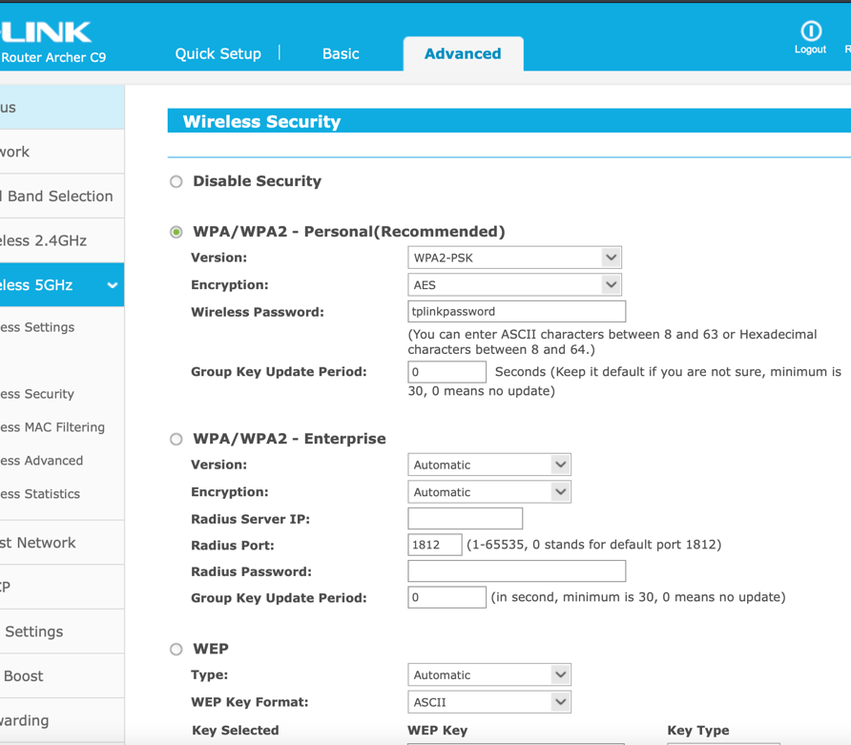

  - Find and go to the MAC address filtering settings, then take and attach a screenshot where you can configure it.

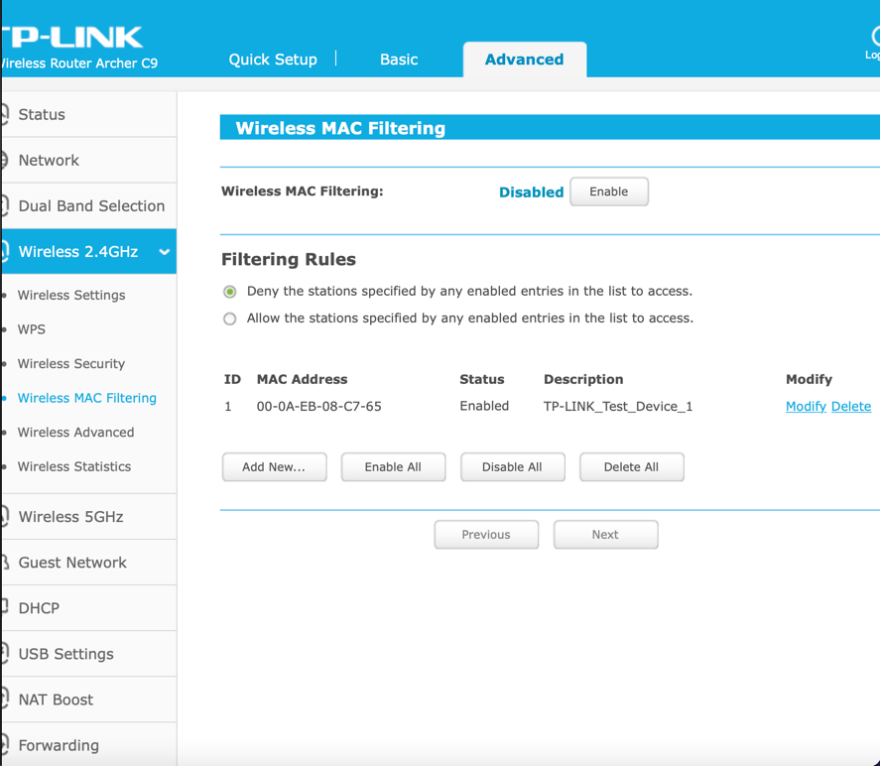
  - Go to router setting where you can hide (disable broadcasting) the SSID of the router. Show screenshot.

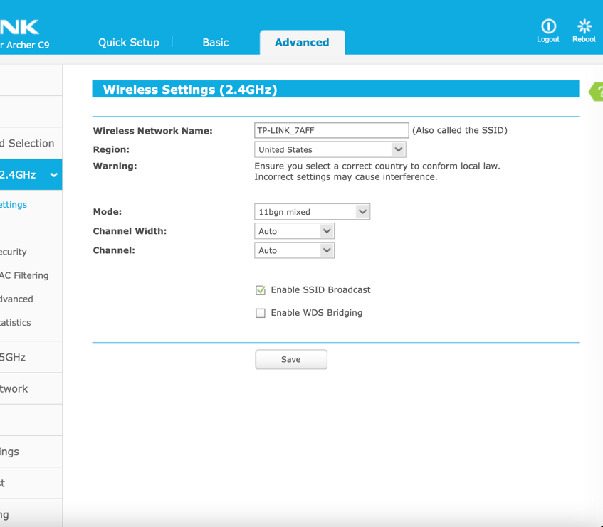

  - What are some settings and suggestions that you think can be used to enhance Wi-Fi security?

Turn On Automatic Updates.
Turn Off Features You Don't Use.
Use Strong Passwords.
Change the Default SSID.
Use WPA3.

Choose one to complete between tasks 4 and 5 below for bonus points.

- WEP Hacking/Evaluation. (up to 15 bonus points)
  - What is the brand and model of the wireless router you are connected to for this hacking/evaluation?

  - What are the IP addresses and MAC addresses of your wireless Network Interface Card (NIC) and the wireless router? What is the subnet mask of this wireless network?

  - Crack the WEP encryption key. You are recommended to use the method (fake authentication and aireplay-ng attack) as introduced in class materials. Log all major steps with screenshots. Make sure your last screenshot shows the WEP key found/cracked.

- WPA/WPA2/WPA3 Hacking/Evaluation. (up to 20 bonus points)
  - What is the brand and model of the wireless router you are connected to for this hacking/evaluation?

  - What are the IP addresses and MAC addresses of your wireless NIC and the wireless router? What is the subnet mask of this wireless network?

  - Hack WPA/WPA2/WPA3 and crack its encryption key. Log all major steps with screenshots. Make sure your last screenshot shows the WPA/WPA2/WPA3 key found/cracked.

